STUDY REGARDING THE FREQUENCY AND CONTRIBUTION OF THE CENTRAL BACK TECHNICAL-TACTICAL ACTIONS IN ATTACK, FOR THE JUNIOR II HANDBALL TEAMS

Şufaru Constantin ¹
Iancu Aurel ²
¹"Vasile Alecsandri" University of Bacau, 157 Marasesti Av., Bacău, 600115, Romania ²Valahia University of Târgovişte, Romania

Keywords: handball, juniors II, central back, contribution
Abstract
This research tried to bring concrete data that could beneficially influence the quality and the contribution of the junior II central back players' attack actions. Presumably, the study of frequency and contribution of the central back technical-tactical actions in attack, for the junior II handball teams could lead to the completion of the game models for this level. From the analysis of the results, one can see that each team's central back frequently use certain technical-tactical actions. The play of certain teams studied here is based very much around the central backs. The official competition game is the most reliable source for real data regarding the contribution of the central back's technical-tactical actions. The evolution of team handball, noticeable mostly during the official competitions, is characterized mainly by the emergence of several new technical-tactical actions that permanently constitute the premises for the creation of new game models for the central backs.

1. Introduction
This research tried to bring concrete data that could beneficially influence the quality and the contribution of the central back players' attack actions.
There is a general orientation to permanently take into consideration these particularities, selecting the most effective exercises, establishing the proportions of the effort, deciding the training stages, etc. (Alexandru, 2003; Bota, 1984; Colibaba-Evuleţ & Bota, 1998; Cercel, 1983).
In this sense, this paper comprises information regarding the contributions of the player specializing as a central back.
Through its contents, this research advocates the following:
- the creation of a balance between theory and practice;
- a change in the thinking and acting of the teachers training the school representative team;
- the promotion of an instructional technology that would ensure the quality and contribution of the central backs' instruction (Budevici & Şufaru, 2005; Şufaru, 2006).
We believe that the practical application of this type of orientations could constitute an important step in increasing the performance skills in team handball.
Through this, we want to bring a small contribution to the optimization of the central back's training process, being a well-known fact that the main assessment criterion for a player's value is his contribution during a game, positive results during competitions, and how many of the set goals are reached.
2. Material and methods
Aim and tasks of the research
The research aimed to assess the effectiveness of the structures of exercises used to model the pupils specialized in playing as central backs, following a set of goals, such as:
- Consulting the specialized literature for establishing the currency of this theme and the level of research in this field;
- Knowing, by studying the bibliography, and by discussing with the coaches and testing several players, how to choose the group of subjects for this research.
- Selecting and systematizing several effective technical-tactical actions that would lead to a quick progress resulting in increased game actions of the central back, which would lead to reaching the set aim and goals;
- Recording and interpreting the results to highlight the frequency and contribution of the central backs, in their dynamics;
- Emphasizing the recorded results and draw conclusions after conducting the study.
The following hypothesis has been formulated, on which this study is based:
- Presumably, the study of frequency and contribution of the central back technical-tactical actions in attack, for the representative handball school team could lead to the completion of the game models for the representative middle school handball teams.
The research was conducted over the course of one year, 2012-2013, mainly at: the gymnasium of School no. 2, Bacau, where we recorded official games during the National School Handball Championship, the area schools phase.
The research methods used in this study were: the study of the professional literature, the observation method, the modeling method, the inquiry method, the analysis based on video images of physical activities, the statistical-mathematical method, and the analysis of the efficiency of the training process.
Research subjects
- This research studied the progress of the male players of the representative handball team that have played as central backs, namely (table 1):
Table 1. The observed players

No. | Initials | Team | Position
1. | CG | School no. 10, Bacau | Central Back
2. | ŞA | School no. 3, Adjud | Central Back
3. | BM | "Ştefan cel Mare" National College, Bacau | Central Back
4. | FV | School no. 2, Bacau | Central Back
5. | AI | School no. 10, Bacau | Central Back
6. | FA | "Ştefan cel Mare" National College, Bacau | Central Back
7. | BA | "Ştefan cel Mare" National College, Bacau | Central Back
8. | BV | School no. 2, Bacau | Central Back

The technical-tactical actions recorded in this study
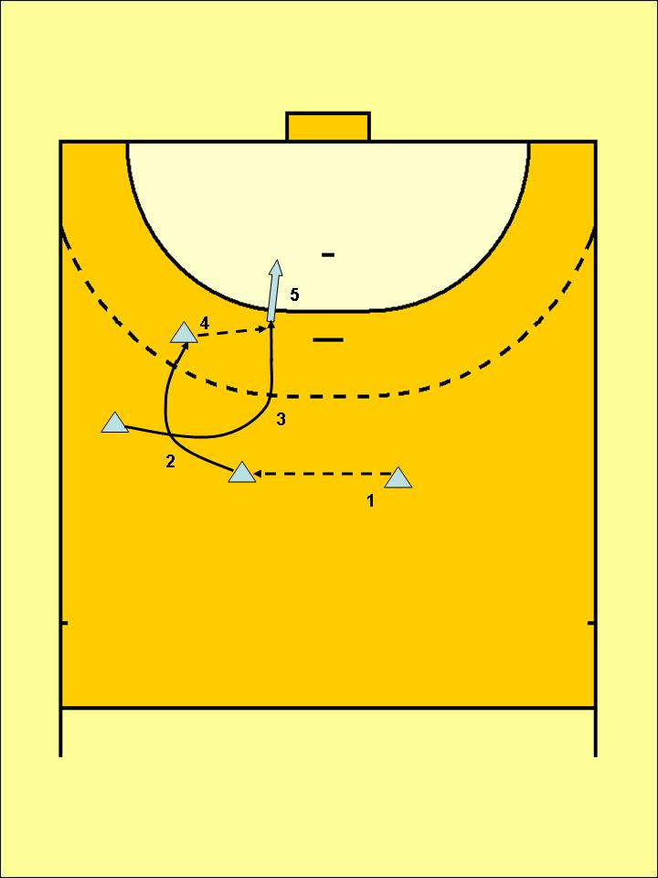
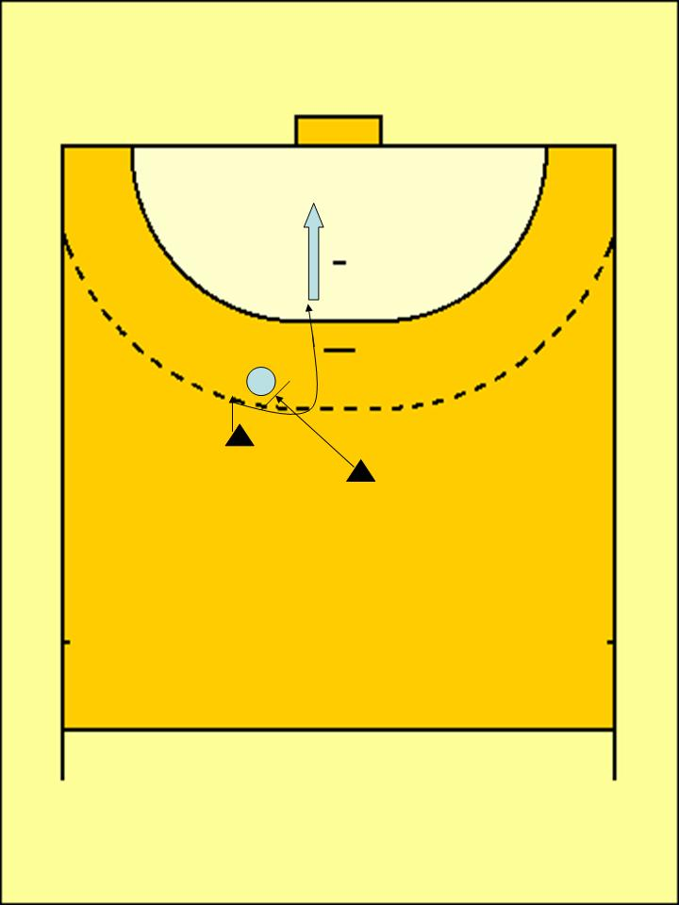
Figure 1. Technical-tactical action 1 Figure 2. Technical-tactical action 2

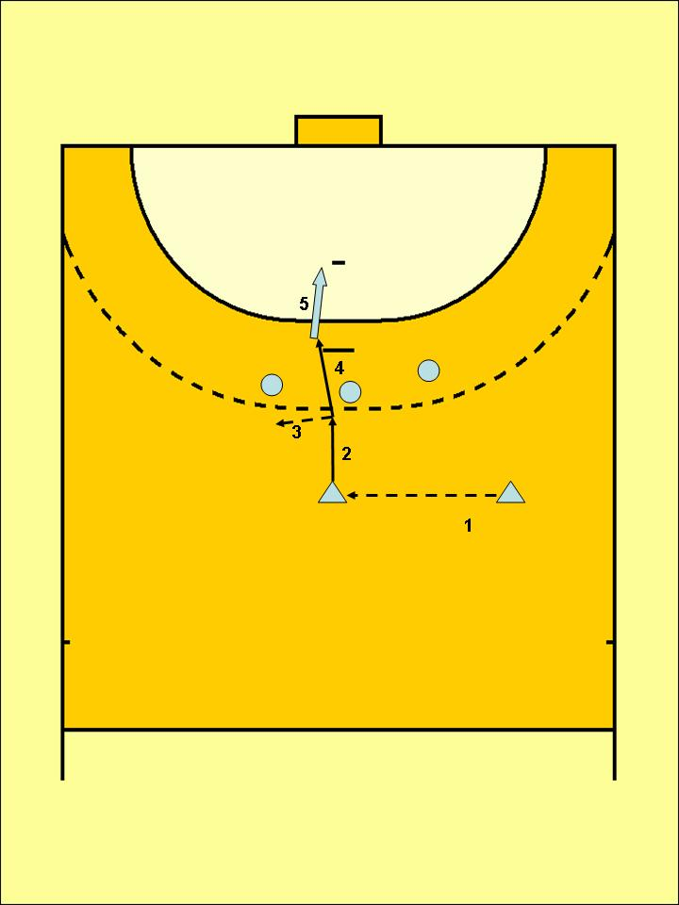
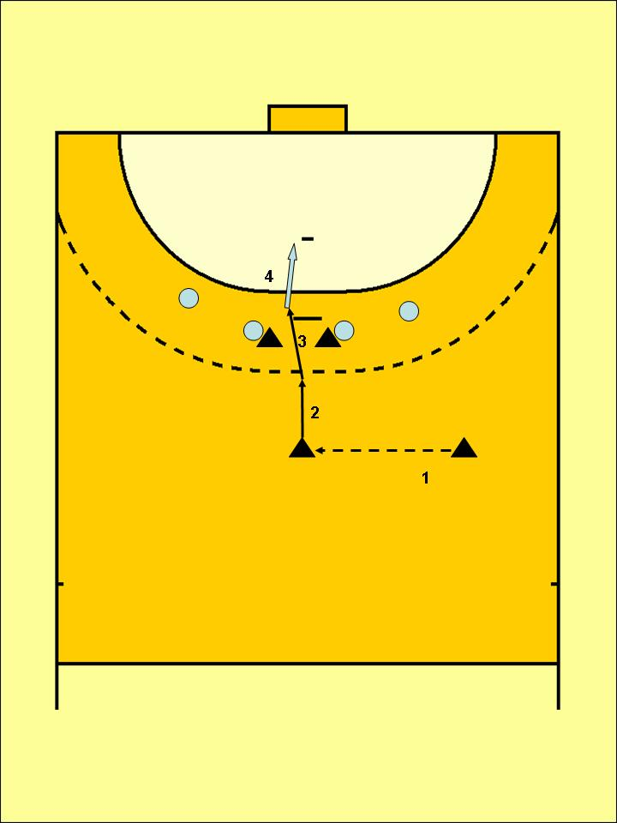
Figure 3. Technical-tactical action 3 Figure 4. Technical-tactical action 4
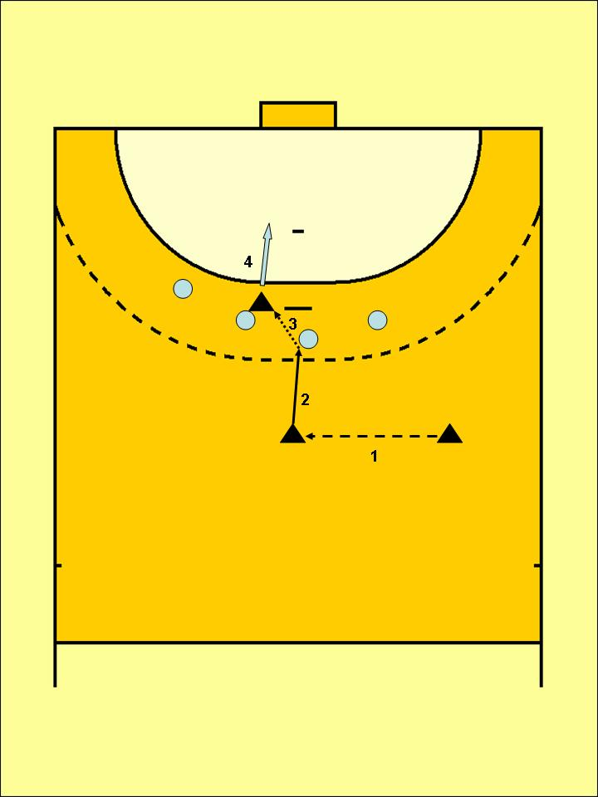
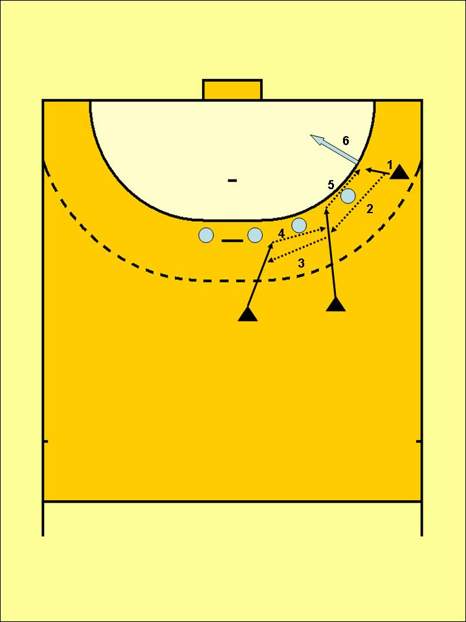

Figure 5. Technical-tactical action 5 Figure 6. Technical-tactical action 6
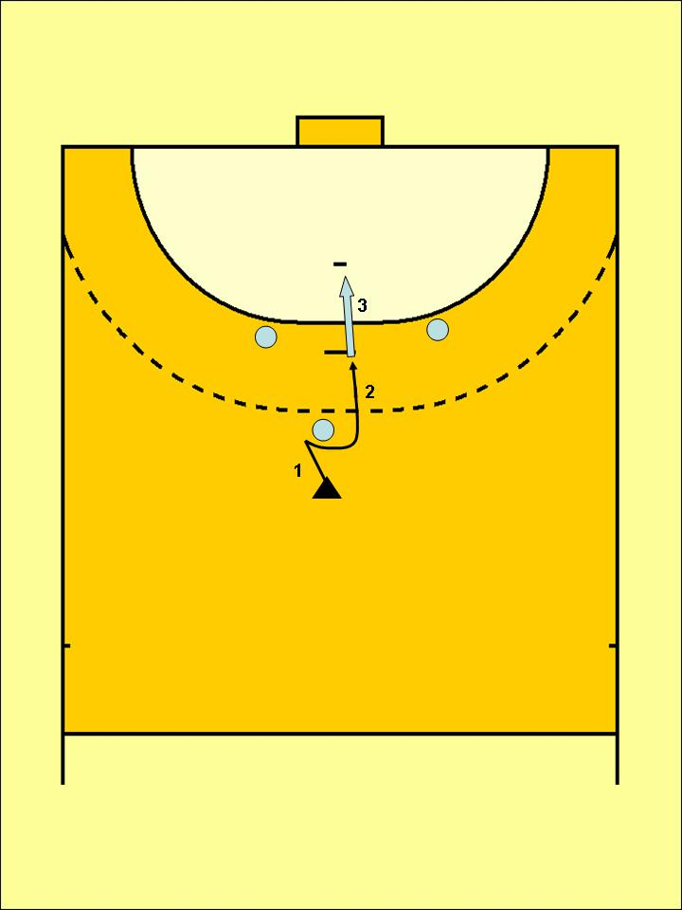
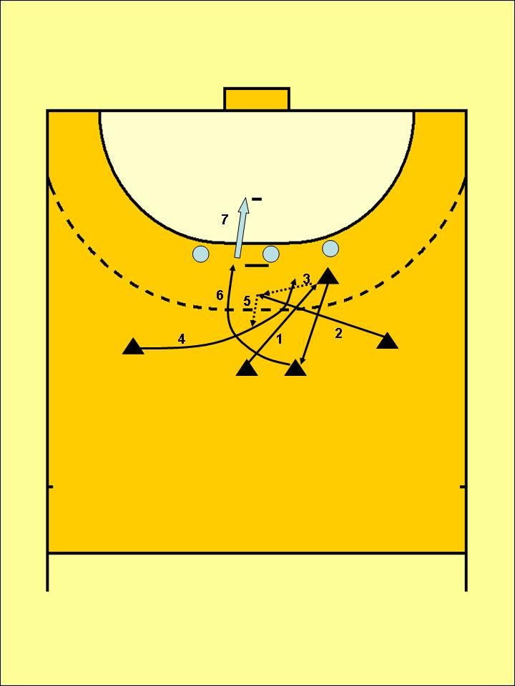
Figure 7. Technical-tactical action 7 Figure 8. Technical-tactical action 8
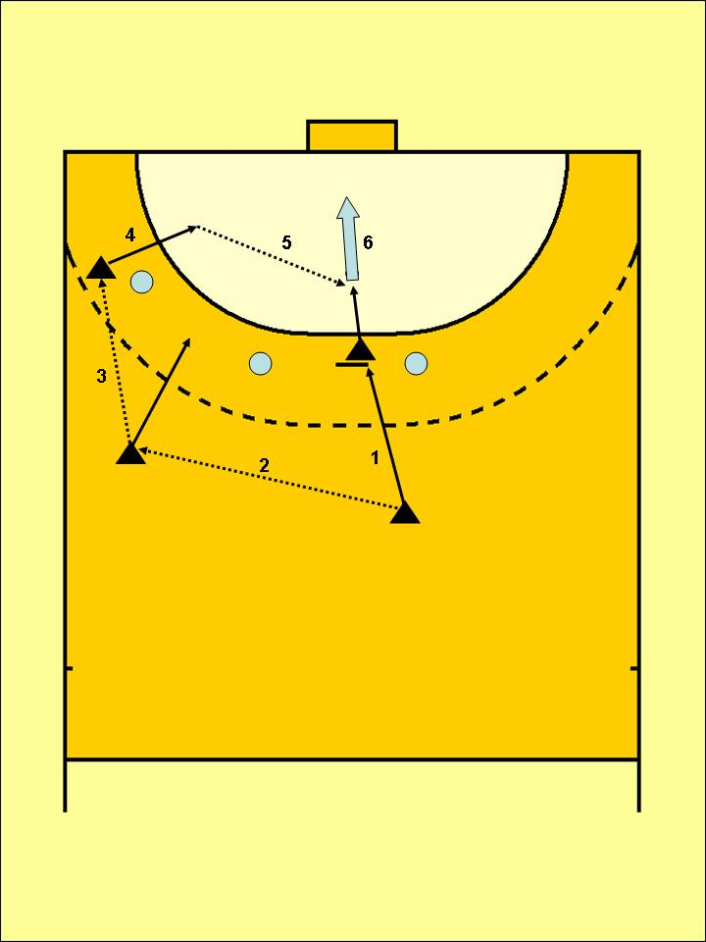
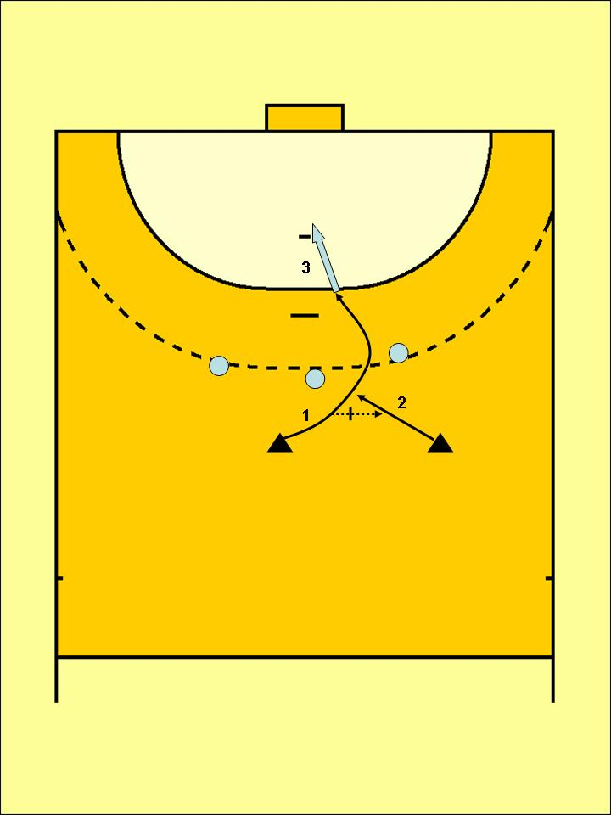
Figure 9. Technical-tactical action 9 Figure 10. Technical-tactical action 10

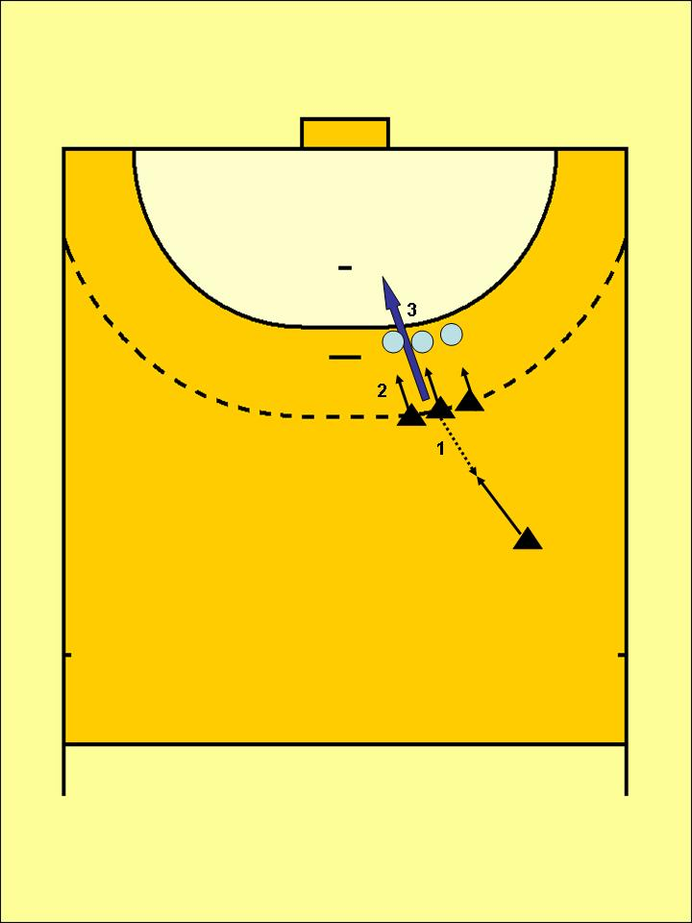
Figure 11. Technical-tactical action 11

The description of the technical-tactical actions:
Technical-tactical action 1 (Tech.-Tac. A. 1 – fig. 1)
The left back (LB) passes to the central back (CB) - CB comes in on the right - the right back (RB) goes behind the ball player (CB) - CB passes to RB - releases a shot at the goal.
Technical-tactical action 2 (Tech.-Tac. A. 2 – fig. 2)
If the back is in a man-to-man situation, CB moves with the ball in the direction of LB, the back getting closer to the direct defender. When CB is in the proximity of the defender, the back fakes a start to the left to make the defender react, then he quickly changes direction to the right, receives the ball through a pass and, freed from the opponent's guarding, continues to act either to score, if that is the case, or to get into combinations with other teammates.
Technical-tactical action 3 (Tech.-Tac. A. 3 – fig. 3)
On the position of L(R)B, CB looks for the shooting path, catches the ball, performs a fake pass to R(L)B, then he releases a jump shot at the goal or he gets into a combination with his teammates.
Technical-tactical action 4 (Tech.-Tac. A. 4 – fig. 4)
CB ranges the pivots in such a way so that the central defenders are blocked, he receives the pass from a back or a wing, after which he releases a shot at the goal on the path created by the pivots' blocking, or he gets into a combination with his teammates.
Technical-tactical action 5 (Tech.-Tac. A. 5 – fig. 5)
On the position of L(R)B, CB threatens the goal with the ball, then he performs a fake jump shot at the goal, followed by the pivot, who will score.
Technical-tactical action 6 (Tech.-Tac. A. 6 – fig. 6)
Passing in successive breakthrough and threatening the goal, starting with the wing, who attacks the outside path, continues passing up to CB, who turns the successive attack toward the back who received the pass. In the meantime, the pivot is blocking the central defender toward the outside. The wing shoots at the goal, or he gets into a combination with other teammates (creating an overcrowd).
Technical-tactical action 7 (Tech.-Tac. A. 7 – fig. 7)
Double criss-cross started by CB with LB, the latter criss-crossing RB, and RB calls CB for an encircling, who will release a jump shot at the goal, or will get into a combination with other teammates.
Technical-tactical action 8 (Tech.-Tac. A. 8 – fig. 8)
Fake pass followed by a simple change in direction, jump shot at the goal, or jump ball with the pivot, or pass to one of the backs who will continue the action.
Technical-tactical action 9 (Tech.-Tac. A. 9 – fig. 9)
CB calls the back for a criss-cross, fake pass to the back, and breakthrough on the path formed by the pivot, followed by a jump shot at the goal.
Technical-tactical action 10 (Tech.-Tac. A. 10 – fig. 10)
The wing goes in front of the lateral defender on the outside, fake shot at the goal, pass to CB who jumps above the semicircle, followed by a in-flight shot at the goal.
Technical-tactical action 11 (Tech.-Tac. A. 11 – fig. 11)
CB performs a wall, retreating with his back to the opponent. This action is encountered very often when performing 9 m throws. After receiving the ball, the back releases a shot at the goal, or leaves the ball to another player in the wall.

3. Results and discussions
An example of recording the frequency of technical-tactical actions used by the central backs is presented next, recorded during official games. Based on these recordings, the frequency of each exercise structure necessary to model the training was calculated and established.
Example:
The game between School no. 10, Bacau, and the "Ştefan cel Mare" National College, Bacau
Final result: 23-22
The frequency of the technical-tactical actions performed by the School no. 10 central back
Total number of technical-tactical actions: 27. (table 2)
Table 2. The recorded technical-tactical actions – frequency coefficient
Technical-tactical action (Technical-tactical A.) | No. of actions | No. of goals | Frequency  coefficient (%)
Technical-tactical A. 1 | 7 | 2 | 25.92%
Technical-tactical A. 2 | 2 | 0 | 7.40%
Technical-tactical A. 3 | 4 | 1 | 14.81%
Technical-tactical A. 4 | 2 | 1 | 7.40%
Technical-tactical A. 5 | 1 | 0 | 3.70%
Technical-tactical A. 6 | 0 | 0 | 0
Technical-tactical A. 7 | 2 | 1 | 7.40%
Technical-tactical A. 8 | 3 | 1 | 11.11%
Technical-tactical A. 9 | 1 | 0 | 3.70%
Technical-tactical A. 10 | 2 | 0 | 7.40%
Technical-tactical A. 11 | 3 | 1 | 11.11%

Recorded subjects:
CG and FA= School no. 10, Bacau
BA = The "Ştefan cel Mare" National College, Bacau
In order to calculate the frequency percentage, the following formula was elaborated:
Frequency percentage = Number of Tech.-Tac. A.”x” X 100
Total number of Tech.-Tac. A.”x” used during the game

After analyzing the data recorded and presented in the tables above, a ranking was established, for the top 4 technical-tactical actions, from the viewpoint of frequency, used in this game by the central backs of the two teams (table 3).
From the analysis of the results, one can see that each team's central back frequently use certain technical-tactical actions, in other words, each team has a certain characteristic in regards to the central backs' play. In this sense, one can say that the play of certain teams studied here is based very much around the central backs.

Table 3. Frequency of the technical-tactical actions recorded during the game between School no. 10, Bacau, and the "Ştefan cel Mare" National College, Bacau

Frequency  School no. 10, Bacau | Frequency  "Ştefan cel Mare" National College, Bacau
1. Tech.-Tac. A. 1 = 25.92% | 1. Tech.-Tac. A. 1 = 19.04%
2. Tech.-Tac. A. 3 = 14.81% | 2. Tech.-Tac. A. 7 = 14.28%
3. Tech.-Tac. A. 8, 11 = 11.11% | 3. Tech.-Tac. A. 3, 4, 6, 8, 11 = 14.28%
4. Tech.-Tac. A. 2, 4, 7, 10 = 25%

We believed it was necessary to present statistically the usage percentage of the technical-tactical actions used by each team throughout every recorded game.
For the next step of the research, we aimed to study, from a statistical-mathematical standpoint, the contribution of the technical-tactical actions recorded throughout this research.
In order to calculate the contribution of each technical-tactical action of the central backs (during the 5 recorded games), we started from the total number of goals scored by the central backs divided by the total number of technical-tactical actions of the central backs, using the formula:

Total contribution percentage = Total no. of goals scored from the technical tactical action "x" X 100
The total number of "x" technical-tactical actions used in all of the games
Global contribution of the central backs' technical-tactical actions
Recorded games: 5
Recorded teams: 6
No. of recorded central backs: 8
Total no. of goals scored by the central backs: 66
Total no. of central backs' technical-tactical actions: 98
Total no. of goals scored by the central backs: 66
Total no. of goals from all of the recorded games: 251

Total contribution = 66 X 100 / 251 = 26.29%
From the previously presented data, one can rank the top technical-tactical actions used by the central backs during the recorded official games that can be used as exercise structures for an adequate modeling for the training of the central backs of the school representative team.
One can see clearly that the first three technical-tactical actions that had a larger contribution, used by the central backs throughout the games recorded during the area tournament of the National School Championship, were the technical-tactical actions no. 1, 2, and 5.
These simple actions that are used very much throughout a game by most central backs, together with other presented game actions, con constitute the most important structures of exercises to model the training of these players.
4. Conclusions
The recording of the frequency and contribution of the technical-tactical actions used during the official competition games by the central back allowed an adequate analysis that supports the initial hypothesis, leading to the following conclusions:
- The official competition game is the most reliable source for real data regarding the contribution of the central back's technical-tactical actions. The evolution of team handball, noticeable mostly during the official competitions, is characterized mainly by the emergence of several new technical-tactical actions that permanently constitute the premises for the creation of new game models for all of the players, including the central backs.
- From the concrete development of the official games recorded during this research, 11 basic technical-tactical actions resulted, with scoring, performed by the central back, individually, or in collaboration with the back or with the pivot.
- This research tried to bring concrete data that could beneficially influence the quality and the contribution of the central back players' attack actions.
- Thus, this research was able to confirm the initial hypothesis, meaning that the study of frequency and contribution of the central back technical-tactical actions in attack, for the representative handball school team really did lead to the completion of the game models for the representative middle school handball teams.
References
- ALEXANDRU E. (2003). Handbal pentru copii şi juniori, Chişinău: Valinex, Republica Moldova;
- BOTA, I. (1984). Handbal - Modele de joc şi pregătire, București: Sport-Turism, România;
- BUDEVICI, A., ŞUFARU, C. (2005). Principii ştiinţifico-metodologice ale pregătirii handbaliştilor junior, Chişinău: Valinex S.A., Republica Moldova;
- CERCEL, P. (1983). Antrenamentul echipelor masculine, București: Sport-Turism;
- COLIBABA-EVULEŢ, D., BOTA, I. (1998). Jocuri Sportive. Teorie şi Metodică. București: Aldin;
- ŞUFARU C. (2006). Handbal III– Jocul de handbal în şcoală şi în activităţile extraşcolare. Iaşi: PIM, Româna.

FRECVENŢA ŞI CONTRIBUŢIA ACŢIUNILOR TEHNICO-TACTICE PE POSTUL DE COORDONATOR PENTRU ECHIPELE DE HANDBAL REPREZENTATIVE DE GIMNAZIU

Şufaru Constantin¹
Iancu Aurel ²
¹Universitatea “Vasile Alecsandri” din Bacău, Calea Mărăşeşti nr. 157, 600115, Bacău, România
² Universitatea Valahia Tîrgovişte, România

Cuvinte cheie: handbal, juniori II, coordonator de joc, contribuţie
Rezumat
Prin această cercetare am încercat să îmbunătăţim calitatea şi contribuţia jocului în atac a jucătorilor specializaţi pe postul de coordonator de joc (centru), în contextul unei echipe reprezentative de gimnaziu. Se presupune că studierea frecvenţei şi contribuţiei acţiunilor tehnico-tactice pe postul de coordonator de joc (centru) la nivelul echipelor de juniori II, ar putea duce la completarea modelului de joc la acest nivel. Din analiza rezultatelor, se observă că centrii fiecărei echipe folosesc frecvent anumite acţiuni tehnico-tactice. Jocul din cadrul competiţiilor oficiale este cel mai în măsură să ofere date reale privind contribuţia acţiunilor tehnico-tactice ale coordonatorului de joc (centru). Evoluţia jocului de handbal, observabilă mai ales în jocurile din cadrul competiţiilor oficiale, este caracterizată în primul rând de apariţia unor acţiuni tehnico-tactice noi, care se constituie permanent în premisele necesare creării unor noi modele de joc pentru coordonatorii de joc (centru).

1. Introducere
În cercetarea de faţă am încercat să contribuim cu date concrete care pot să influenţeze benefic calitatea şi contribuţia jocului în atac a elevilor specializaţi pe postul de coordonator de joc (centru).
Există o orientare generală, în care se ţine în permanenţă seama de aceste particularităţi, se selecţionează exerciţiile cele mai eficiente, se stabilesc proporţiile efortului, se hotărăşte ponderea laturilor pregătirii, etc. (Alexandru, 2003, Bota, 1984; Colibaba-Evuleţ & Bota, 1998; Cercel, 1983).
În acest sens, lucrarea de faţă cuprinde informaţii diferite cu privire la contribuţia jucătorului specializat pe postul de centru.
Prin conţinutul cercetării de faţă se militează pentru următoarele orientări:
- crearea unui echilibru între teorie şi practică;
- schimbarea mentalităţii de gândire şi acţionare a profesorilor care antrenează echipa reprezentativă a şcolii;
- promovarea unei tehnologii instrucţionale care să asigure calitatea şi contribuţia instruirii, jucătorilor specializaţi pe postul de coordonator de joc (Budevici & Şufaru, 2005; Şufaru, 2006).
Considerăm că aplicarea în practică a acestor tipuri de orientări ar constitui un pas însemnat în dobândirea capacităţii de performanţă, în jocul de handbal.
Prin aceasta, dorim să aducem o modestă contribuţie la optimizarea procesului de pregătire a jucătorului specializat pe postul de coordonator de joc, ştiut fiind faptul că principalul criteriu de apreciere al valorii jucătorilor, îl constituie, contribuţia în joc, rezultatele pozitive în competiţii, măsura în care sunt atinse obiectivele stabilite.
2. Material şi metode
Obiectivele şi sarcinile cercetării
Cercetarea având ca scop evaluarea eficacităţii structurilor de exerciţii folosite în modelarea elevilor specializaţi pentru postul de coordonator de joc, a urmărit o serie de obiective, cum ar fi:
- Consultarea literaturii de specialitate pentru a stabili gradul de actualitate al temei şi nivelul la care se află cercetările în domeniu;
- Cunoaşterea, prin studierea bibliografiei, prin discuţii purtate cu antrenorii şi testarea unor jucători, pentru definirea eşantionului de subiecţi care se încadrează în cerinţele cercetării;
- Selectarea şi sistematizarea unor acţiuni tehnico-tactice eficiente, capabile să ducă la un progres rapid, scontat în creşterea contribuţiei acţiunilor de joc, a jucătorului specializat pe postul de coordonator de joc şi care să servească la atingerea scopului şi obiectivelor propuse;
- Înregistrarea şi interpretarea permanentă a rezultatelor obţinute, pentru a evidenţia frecvenţa şi contribuţia elevilor specializaţi pe postul de coordonator de joc, în dinamica lor;
- Evidenţierea rezultatelor obţinute şi a concluziilor desprinse în urma aplicării cercetării noastre.
În desfăşurarea prezentei cercetări, am stabilit următoarea ipoteză de lucru cu care vom opera pe parcursul desfăşurării prezentului studiu.
- Se presupune că studierea frecvenţei şi contribuţiei acţiunilor tehnico-tactice pe postul de coordonator de joc (centru) la nivelul echipei reprezentative de handbal a şcolii generale, ar putea duce la completarea modelului de joc la nivelul echipelor reprezentative de gimnaziu la acest nivel;
Cercetarea s-a desfăşurat pe perioada unui an, respectiv 2012-2013, având drept loc principal de desfăşurare: Sala Şcolii generale nr. 2 din Bacău în care am înregistrat partide oficiale desfăşurate în Campionatul Naţional Şcolar de Handbal., faza pe zonă la nivelul şcolilor generale.
Metodele de cercetare folosite au fost următoarele: studiul materialului de specialitate, metoda observaţiei, metoda modelării, metoda anchetei, analiza pe baza imaginilor video a activităţilor corporale, metoda statistico-matematică şi analiza randamentului procesului de pregătire.
Subiecţii cercetării
- Pentru efectuarea cercetării am urmărit evoluţia componenţilor echipelor reprezentative şcolare de handbal masculin, care au evoluat pe postul de coordonator de joc şi anume (tabel 1):

Tabel 1. Jucătorii observaţi
Nr. crt. | Iniţialele jucătorilor | Echipa | Postul de bază
1. | CG | Şcoala Generală nr. 10 Bacău | Centru
2. | ŞA | Şcoala Generală nr. 3 Adjud | Centru
3. | BM | Colegiul Naţional „Ştefan cel Mare” Bacău | Centru
4. | FV | Şcoala Generală nr. 2 Bacău | Centru
5. | AI | Şcoala Generală nr. 10 Bacău | Centru
6. | FA | Colegiul Naţional „Ştefan cel Mare” Bacău | Centru
7. | BA | Colegiul Naţional „Ştefan cel Mare” Bacău | Centru
8. | BV | Şcoala Generală Nr. 2 Bacău | Centru

Acţiunile tehnico – tactice înregistrate în cercetarea noastră au fost:

Figura 1. Acţiunea tehnico-tactică 1 Figura 2. Acţiunea tehnico-tactică 2

Figura 3. Acţiunea tehnico-tactică 3 Figura 4. Acţiunea tehnico-tactică 4

Figura 5. Acţiunea tehnico-tactică 5 Figura 6. Acţiunea tehnico-tactică 6

Figura 7. Acţiunea tehnico-tactică 7 Figura 8. Acţiunea tehnico-tactică 8

Figura 9. Acţiunea tehnico-tactică 9 Figura 10. Acţiunea tehnico-tactică 10

Figura 11. Acţiunea tehnico-tactică 11

Iată descrierea acţiunilor tehnico-tactice:

Acţiunea tehnico-tactică nr. 1 (A. th-ta. 1 – fig. 1)
Interul stâng pasează la centru – centrul pătrunde spre dreapta – interul drept trece prin spatele celui cu mingea (centru) – centrul pasează interului dreapta - finalizare cu aruncare la poartă.
Acţiunea tehnico-tactică nr. 2 (A. th-ta. 2 – fig. 2)
În situaţia în care interul este luat om la om, centrul se deplasează cu mingea în direcţia postului interului stâng, interul apropiindu-se de apărătorul direct. În momentul în care centrul se găseşte în apropierea apărătorului, interul face o fentă de pornire spre stânga, pentru a-l determina pe apărător să reacţioneze, apoi acesta schimbă brusc direcţia de deplasare spre dreapta, primeşte mingea printr-o pasă oferită şi, scăpat de sub marcajul adversarului, acţionează în continuare fie pentru a arunca la poartă, dacă este cazul, fie pentru a intra în combinaţii cu alţi coechipieri.
Acţiunea tehnico-tactică nr. 3 (A. th-ta. 3 – fig. 3)
Pe pasul de la interul stâng (drept), centrul caută culoarul de aruncare, prinde mingea, execută o fentă de pasă la interul drept (stâng), după care aruncă la poartă din săritură sau intră în combinaţie cu coechipierii.
Acţiunea tehnico-tactică nr. 4 (A. th-ta. 4 – fig. 4)
Centrul aşează pivoţii astfel încât apărătorii centrali să fie blocaţi, primeşte pasa de la un inter sau o extremă, după care execută aruncare la poartă prin culoarul creat de blocajul pivoţilor, au intră în combinaţie cu ceilalţi jucători.
Acţiunea tehnico-tactică nr. 5 (A. th-ta. 5 – fig. 5)
Pe pasul interului stâng (drept), centrul ameninţă poarta cu mingea după care execută fentă de aruncare la poartă din săritură sau din săritură, urmată de angajarea pivotului, care va finaliza.
Acţiunea tehnico-tactică nr. 6 (A. th-ta. 6 – fig. 6)
Pasare în pătrundere succesivă cu ameninţarea porţii, începând de la extremă, care atacă culoarul exterior, continuă pasarea până la centru care întoarce atacul succesiv spre interul de la care a primit pasa. În acest timp pivotul blochează apărătorul central spre exterior. Extrema va arunca la poartă, sau va intra în combinaţie cu alţi coechipieri (se va crea un supranumeric).
Acţiunea tehnico-tactică nr. 7 (A. th-ta. 7 – fig. 7)
Încrucişare dublă începută de către centru cu interul stânga, acesta din urmă încrucişează cu interul dreapta, iar interul dreapta cheamă la învăluire centrul, care va finaliza din săritură, sau va intra în combinaţie cu ceilalţi coechipieri.
Acţiunea tehnico-tactică nr. 8 (A. th-ta. 8 – fig. 8)
Fentă de pasare urmată de schimbare simplă de direcţie, aruncare la poartă din săritură, sau angajarea pivotului, sau pasă la unul dintre interi care vor continua acţiunea.
Acţiunea tehnico-tactică nr. 9 (A. th-ta. 9 – fig. 9)
Centrul cheamă la încrucişare interul, fentă de pasă la inter, şi pătrundere în culoarul format de pivot, urmat de aruncare la poartă din săritură.
Acţiunea tehnico-tactică nr. 10 (A. th-ta. 10 – fig. 10)
Extrema depăşeşte apărătorul lateral prin exterior, fentă de aruncare la poartă, pasă la centru care se află în săritură deasupra semicercului, urmată de finalizare („aeriană”).
Acţiunea tehnico-tactică nr. 11 (A. th-ta. 11 – fig. 11)
Centrul execută paravan, retrăgându-se cu spatele la adversar. Această acţiune o întâlnim foarte des la executarea aruncărilor de la 9 m. După primirea mingii interul aruncă la poartă, sau lasă mingea unui jucător aflat în paravan.
3. Rezultate şi discuţii
În continuare, vom prezenta un exemplu de înregistrare a frecvenţei acţiunilor tehnico-tactice care au fost utilizate de jucătorii specializaţi pe postul de coordonator de joc şi înregistrate în jocuri oficiale. Pe baza acestor înregistrări, am calculat şi stabilit frecvenţa fiecărei structuri de exerciţii necesare în modelarea pregătirii.
Exemplu:
Meciul Şcoala generală nr. 10 Bacău - Colegiul Naţional „Ştefan cel Mare” Bacău
Rezultat final: 23-22
Frecvenţa acţiunilor tehnico-tactice ale centrului echipei Şc. gen. nr. 10 Bacău
Număr total acţiuni tehnico-tactice: 27. (tabel 2)

Tabel 2. Acţiunile tehnico-tactice înregistrate – coeficientul de frecvenţă

Acţiunea tehnico-tactică | Număr acţiuni | Număr goluri | Coeficient frecvenţă (%)
A. tehnico-tactică 1 | 7 | 2 | 25,92%
A. tehnico-tactică 2 | 2 | 0 | 7,40%
A. tehnico-tactică 3 | 4 | 1 | 14,81%
A. tehnico-tactică 4 | 2 | 1 | 7,40%
A. tehnico-tactică 5 | 1 | 0 | 3,70%
A. tehnico-tactică 6 | 0 | 0 | 0
A. tehnico-tactică 7 | 2 | 1 | 7,40%
A. tehnico-tactică 8 | 3 | 1 | 11,11%
A. tehnico-tactică 9 | 1 | 0 | 3,70%
A. tehnico-tactică 10 | 2 | 0 | 7,40%
A. tehnico-tactică 11 | 3 | 1 | 11,11%

Subiecţii înregistraţi:
CG şi FA= Şcoala generală nr. 10 Bacău
BA = Colegiul Naţional. „Ştefan cel Mare” Bacău
Pentru a calcula procentul de frecvenţă am elaborat următoarea formulă de calcul:

Procent de frecvenţă = ^{Numărul A. Th.- Ta.”x” X 100}
Numărul total de A. Th.-Ta. ”x” folosite în meci

În urma datelor înregistrate şi prezentate în tabelele anterioare am stabilit un clasament al primelor 4 acţiuni tehnico-tactice, din punct de vedere al frecvenţei, folosite în acest meci de centrii celor două echipe (tabel 3).
Din analiza rezultatelor obţinute, se observă că fiecare echipă, mai exact centrii fiecărei echipe, folosesc frecvent anumite acţiuni tehnico-tactice, altfel spus, fiecare echipă are o anumită caracteristică a jocului centrilor. Putem afirma în acest sens că jocul anumitor echipe cercetate, se bazează foarte mult pe jocul centrilor.

Tabel 3. Frecvenţa acţiunilor tehnico-tactice în meciul
Şcoala Generală Nr. 10 Bacău - Colegiul Naţional „Ştefan cel Mare” Bacău

Frecvenţa  Şcoala Generală Nr. 10 Bacău | Frecvenţa  Colegiul Naţional „Ştefan cel Mare” Bacău
1. A. Th- Ta 1 = 25,92% | 1. A. Th-Ta 1= 19,04%
2. A. Th- Ta 3 = 14,81% | 2. A. Th-Ta 7 = 14,28%
3. A. Th- Ta 8 , 11= 11,11% | 3. A. Th-Ta 3, 4, 6, 8, 11 = 14,28%
4. A. Th- Ta 2,4,7,10 = 25%

În acest sens, am considerat necesar să prezentăm statistic procentajul de utilizare a acţiunilor tehnico-tactice utilizate de fiecare echipă pe parcursul tuturor meciurilor înregistrate.
Pentru următorul pas al prezentei cercetări ne-am propus să analizăm din punct de vedere statistico-matematic contribuţia acţiunilor tehnico-tactice înregistrate pe tot parcursul cercetării.
Pentru a putea calcula contribuţia fiecărei acţiuni tehnico-tactice în parte a centrilor (în cele 5 partide înregistrate) am pornit de la numărul total de goluri înscrise de centri raportat la numărul total de acţiuni tehnico-tactice ale centrilor, pe tot parcursul înregistrărilor, utilizând formula:

Procent contribuţie totală = Nr. total de goluri înscrise din A. tehnico-tactică „x” X 100
Nr. total de A. tehnico-tactice „x” folosite în toate meciurile
Contribuţia globală a acţiunilor tehnico-tactice ale centrilor
Partide înregistrate: 5
Echipe înregistrate: 6
Nr. centri înregistraţi: 8
Numărul total de goluri înscrise de centri: 66
Numărul total de acţiuni tehnico-tactice ale centrilor: 98
Numărul total de goluri înscrise de centri: 66
Numărul total de goluri din toate partidele înregistrate: 251
Contribuţia totală = 66 X 100 / 251 = 26,29%
Din cele prezentate anterior putem desprinde clasamentul primelor acţiuni tehnic-tactice utilizate de centri în jocurile oficiale înregistrate, care pot fi folosite ca structuri de exerciţii pentru o modelare adecvată a pregătirii jucătorilor specializaţi pe postul de coordonator de joc din cadrul echipei reprezentative a şcolii.
Se desprinde clar că, primele trei acţiuni tehnico-tactice cu o contribuţie mai mare, folosite de coordonatorii de joc, pe parcursul jocurilor înregistrate din turneul pe zonă din cadrul Campionatului Naţional Şcolar, au fost acţiunile tehnico-tactice nr. 1, 2 şi 5.
Aceste acţiuni simple şi foarte folosite de cele mai multe ori pe parcursul jocului şi de marea majoritate a centrilor şi împreună cu celelalte acţiuni de joc prezentate, pot constitui cele mai importante structuri de exerciţii pentru modelarea pregătirii acestor jucători.
4. Concluzii
Înregistrarea frecvenţei şi contribuţiei acţiunilor tehnico-tactice în jocurile din cadrul competiţiilor oficiale, folosite de jucătorul specializat pe postul de coordonator de joc (centru) ne-a permis o analiză adecvată în sprijinul ipotezelor formulate la începutul cercetării şi a dus la conturarea următoarelor concluzii:
- Jocul din cadrul competiţiilor oficiale, este cel mai în măsură să ofere date reale privind contribuţia acţiunilor tehnico-tactice pentru postul de coordonator de joc (centru). Evoluţia jocului de handbal, observabilă mai ales în jocurile din cadrul competiţiilor oficiale, este caracterizată în primul rând de apariţia unor acţiuni tehnico-tactice noi, care se constituie permanent în premisele necesare creării unor noi modele de joc, pentru toţi jucătorii, deci şi pentru ce specializaţi pe postul de coordonator de joc (centru).
- Din desfăşurarea concretă a jocurilor oficiale înregistrate pe parcursul cercetării, au rezultat la acest nivel de vârstă, 11 acţiuni tehnico-tactice de bază, cu finalizare, executate de jucătorul specializat pe postul de coordonator de joc (centru), individual sau în colaborare cu interul sau pivotul.
- În cercetarea de faţă am încercat să contribuim cu date concrete care pot să influenţeze benefic calitatea şi contribuţia jocului în atac a elevilor specializaţi pe postul de coordonator de joc (centru).
În acest sens, în prezenta cercetare, s-a putut confirma ipoteza de lucru cu care am operat pe parcursul desfăşurării prezentului studiu, şi anume că studierea frecvenţei şi contribuţiei acţiunilor tehnico-tactice pe postul de coordonator de joc (centru) la nivelul echipei reprezentative de handbal a şcolii generale, ar putea duce la completarea modelului de joc la nivelul echipelor reprezentative de gimnaziu la acest nivel.

E-mail: sufaruconstantin@yahoo.com, tel. 0742993558

